ERD-Description Document

<Clinic Appointment and Queue Management System>

Project Manager: Syed Farhal Abbas

Project Team: Farhal Abbas, Najaf Ali

Clinic Appointment & Queue Management System
Entity & Attribute Reference Document
Database Design — ER Modeling
1. Person (Superclass)
- Registration-ID (PK)
- Name
- Age
- Email
- Gender
2. Patient (Subclass)
- Patient-ID (PK)
- Registration-ID (FK)
3. Doctor (Subclass)
- Doctor-ID (PK)
- Registration-ID (FK)
- Specialization
- License-No
4. Nurse (Subclass)
- Nurse-ID (PK)
- Registration-ID (FK)

5. Medical Record
- Record-ID
- Appointment-ID
- Patient-ID (FK)
6. Payment
- Payment-ID (PK)
- Transaction-ID
- Appointment-ID (FK)
- Amount
- Sales-Tax
- Status (e.g., Paid, Pending)
7. Prescription
- Prescription-ID (PK)
- Appointment-ID (FK)
- Date-Generated

8. Doctor-Schedule
- Schedule-ID (PK)
- Day
- Time
- Doctor-ID
- Start-Time
- End-Time
9. Vitals
- Vitals-ID (PK)
- Vitals (e.g., Blood Pressure/Temp)
- Time
- Patient-ID
- Nurse-ID (FK)

10. Appointment
- Appointment-ID (PK)
- Patient-ID (FK)
- Doctor-ID (FK)
- Appointment-Date
- Appointment-Time
11. Assigned (Assistant/Staff Assignment)
- Assistant-ID (PK)
- Doctor-ID (PK)
- Nurse-ID (FK)

12. Medicine
- Medicine-ID (PK)
- Medicine-Name
13. Prescribed Medicine
- Prescription-ID (FK)
- Medicine-ID (FK)
- Dosage
14. Queue
- Queue-ID (PK)
- Appointment-ID (FK)
- Priority (e.g., Emergency, Routine)

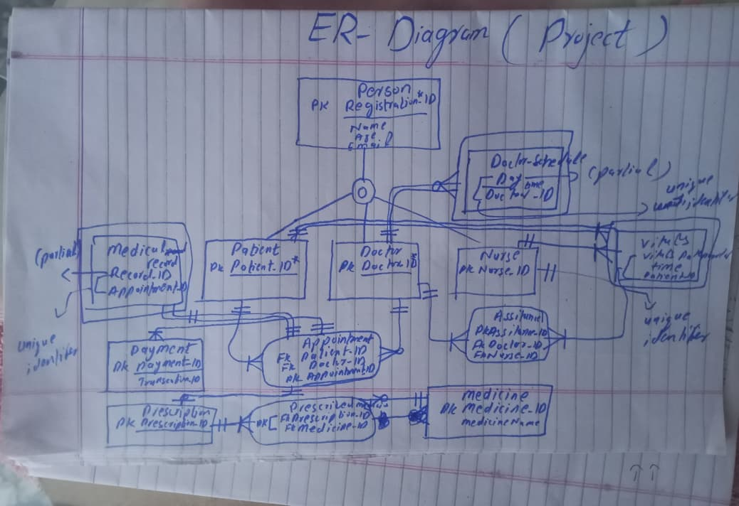

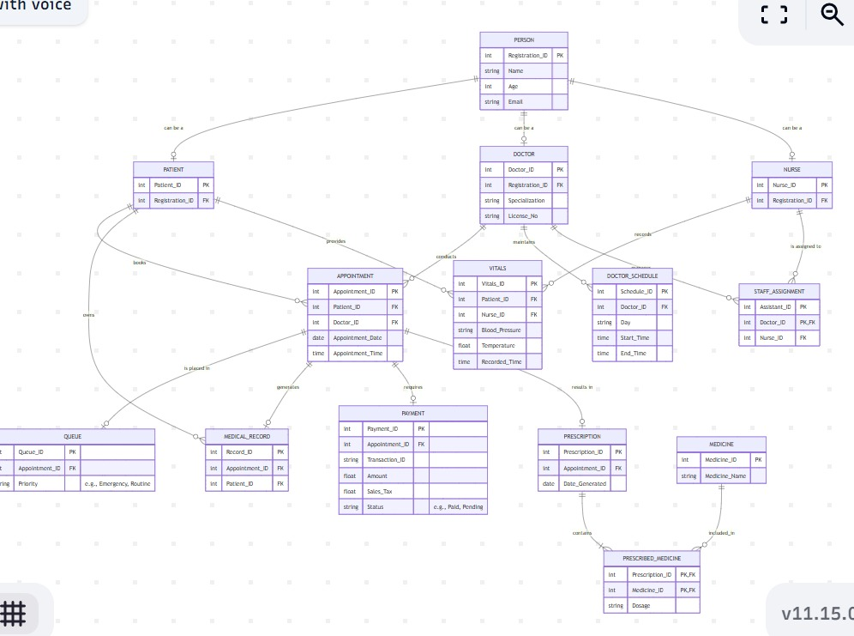

DATABASE:

CREATE TABLE Patient
(
Patient_Id INT AUTO_INCREMENT NOT Null PRIMARY KEY,
Patient_Name VARCHAR(50),
P_Contact VARCHAR(50),
DOB DATE);

//

CREATE TABLE Doctor
(
Doctor_Id INT AUTO_INCREMENT PRIMARY KEY,
Doctor_Name VARCHAR(50),
Specialization VARCHAR(50),
License_No VARCHAR(50)
);

CREATE TABLE Appointment
(
Apt_Id INT AUTO_INCREMENT NOT NUll PRIMARY KEY,
Doctor_Id INT,
Patient_Id INT,
Apt_Date DATE,
Apt_Time Time,
FOREIGN KEY(Doctor_Id) REFERENCES Doctor(Doctor_Id),
FOREIGN KEY (Patient_Id) REFERENCES patient(Patient_Id));

//

CREATE TABLE QUEUE
(
Q_Id INT AUTO_INCREMENT NOT Null PRIMARY KEY,
Apt_Id INT,
Priority VARCHAR(50),
FOREIGN KEY (Apt_Id) REFERENCES Appointment(Apt_Id));

Attributes in Tables:
INSERT INTO Patient (Patient_Name, P_Contact, DOB)
VALUES
('Najaf Ali', '0312', '2025-03-01'),
('Farhal', '0314', '2025-04-01');

//

INSERT INTO Doctor (Doctor_Name, Specialization, License_No)
VALUES
('Dr.Thomas', 'Cardiology', 'LMS30'),
('Dr.Hamdani', 'Neurology', 'LMS31');

//

INSERT INTO Appointment (Doctor_Id, Patient_Id, Apt_Date, Apt_Time)
VALUES (2, 1, '2026-03-31', '10:00:00');

//

INSERT INTO QUEUE (Apt_Id, Priority)
VALUES (1, 'Emergency');

Example Queries:

SELECT
p.Patient_Id,
p.Patient_Name,
d.Doctor_Id,
d.Doctor_Name,
a.Apt_Date,
a.Apt_Time
FROM Appointment AS a
JOIN Patient AS p
ON a.Patient_Id = p.Patient_Id
JOIN Doctor AS d
ON a.Doctor_Id = d.Doctor_Id;

